Designs

**Course: - Software Engineering Principles**

### Slot: - L59 + L60

**Software Design Specification**

# Structure chart

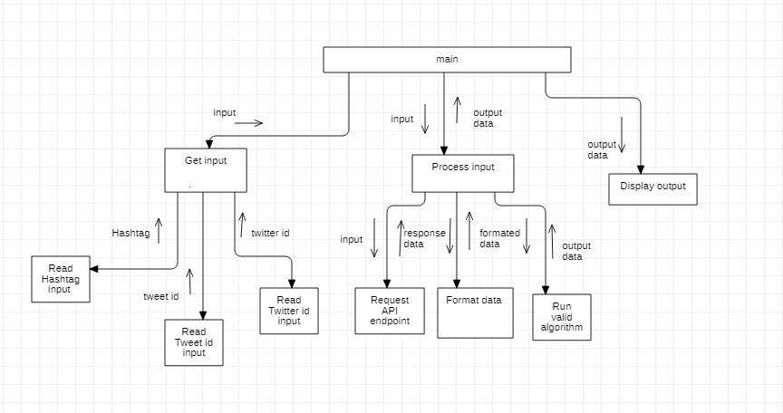

**Use case Diagram**

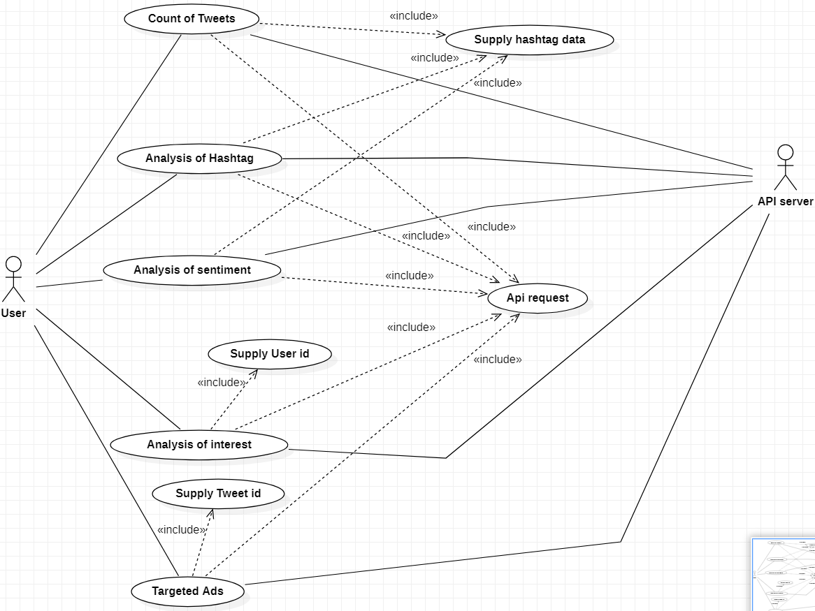

# Use case description

### Count of Tweets

|  |  |  |  |
| --- | --- | --- | --- |
| Use Case ID: | 1 | | |
| Use Case Name: | Count of Tweets | | |
| Created By: | Krithiik | Last Updated By: | Dhiyanesh |
| Date Created: | 21/10/2021 | Date Last Updated: | 21/10/2021 |

|  |  |
| --- | --- |
| Actor: | User, API Server |
| Description: | Given the Hashtag it shows the total tweets tweeted |
| Preconditions: | NA |
| Postconditions: | Display of total Tweet counts |
| Priority: | 5 |
| Frequency of Use: | High |
| Normal Course of Events: | 1. Send an API request to API server 2. Process received data and display output |
| Alternative Courses: | 1. Request Timed out 2. No sufficient data |
| Exceptions: | NA |
| Includes: | Supply hashtag data, API request |
| Special Requirements: | NA |
| Assumptions: | NA |
| Notes and Issues: | NA |

**Analysis of Hashtag**

|  |  |  |  |
| --- | --- | --- | --- |
| Use Case ID: | 2 | | |
| Use Case Name: | Analysis of hashtag | | |
| Created By: | Dhiyanesh | Last Updated By: | Krithiik |
| Date Created: | 21/10/2021 | Date Last Updated: | 21/10/2021 |

|  |  |
| --- | --- |
| Actor: | User, API Server |
| Description: | Given the Hashtag it shows details such as likes, retweets, tweet id,  user id… |
| Preconditions: | NA |
| Postconditions: | Display of likes, retweets, tweet id, user id… |
| Priority: | 5 |
| Frequency of Use: | High |
| Normal Course of Events: | 1. Send an API request to API server 2. Process received data and display output |
| Alternative Courses: | 1. Request Timed out 2. No sufficient data |
| Exceptions: | NA |
| Includes: | Supply hashtag data, API request |
| Special Requirements: | NA |
| Assumptions: | NA |
| Notes and Issues: | NA |

|  |  |  |  |
| --- | --- | --- | --- |
| Use Case ID: | 3 | | |
| Use Case Name: | Analysis of Sentiment | | |
| Created By: | Harshitha | Last Updated By: | Krithiik |
| Date Created: | 21/10/2021 | Date Last Updated: | 21/10/2021 |

|  |  |
| --- | --- |
| Actor: | User, API Server |
| Description: | Given the Hashtag it shows the sentiment of the tweet as positive/ negative /neutral |
| Preconditions: | NA |
| Postconditions: | Display of sentiment of the tweet as positive/ negative /neutral |
| Priority: | 5 |
| Frequency of Use: | High |
| Normal Course of Events: | 1. Send an API request to API server 2. Process received data and display output |
| Alternative Courses: | 1. Request Timed out 2. No sufficient data |
| Exceptions: | NA |
| Includes: | Supply hashtag data, API request |
| Special Requirements: | NA |
| Assumptions: | NA |
| Notes and Issues: | NA |

|  |  |  |  |
| --- | --- | --- | --- |
| Use Case ID: | 4 | | |
| Use Case Name: | Analysis of Interest | | |
| Created By: | Krithiik | Last Updated By: | Harshitha |
| Date Created: | 21/10/2021 | Date Last Updated: | 21/10/2021 |

|  |  |
| --- | --- |
| Actor: | User, API Server |
| Description: | Given the user id it shows their domains of interest |
| Preconditions: | NA |
| Postconditions: | Display of user’s domains of interest |
| Priority: | 5 |
| Frequency of Use: | High |
| Normal Course of Events: | 1. Send an API request to API server 2. Process received data and display output |
| Alternative Courses: | 1. Request Timed out 2. No sufficient data |
| Exceptions: | NA |
| Includes: | Supply user id , API request |
| Special Requirements: | NA |
| Assumptions: | NA |
| Notes and Issues: | NA |

|  |  |  |  |
| --- | --- | --- | --- |
| Use Case ID: | 5 | | |
| Use Case Name: | Targeted ADS | | |
| Created By: | Dhiyanesh | Last Updated By: | Harshitha |
| Date Created: | 21/10/2021 | Date Last Updated: | 21/10/2021 |

|  |  |
| --- | --- |
| Actor: | User, API Server |
| Description: | Given the Tweet id it determines the people who are interested in that tweet |
| Preconditions: | NA |
| Postconditions: | Display’s people who are interested in that tweet |
| Priority: | 5 |
| Frequency of Use: | High |
| Normal Course of Events: | 1. Send an API request to API server 2. Process received data and display output |
| Alternative Courses: | 1. Request Timed out 2. No sufficient data |
| Exceptions: | NA |
| Includes: | Supply tweet id , API request |
| Special Requirements: | NA |
| Assumptions: | NA |
| Notes and Issues: | NA |

|  |  |  |  |
| --- | --- | --- | --- |
| Use Case ID: | 6 | | |
| Use Case Name: | Supply Hashtag | | |
| Created By: | Harshitha | Last Updated By: | Krithiik |
| Date Created: | 21/10/2021 | Date Last Updated: | 21/10/2021 |

|  |  |
| --- | --- |
| Actor: | NA |
| Description: | Gets Hashtag as input from the user |
| Preconditions: | NA |
| Postconditions: | Sends the input data to the following use cases   1. Count of tweets 2. Analysis of hashtag 3.Analysis of interest |
| Priority: | 5 |
| Frequency of Use: | Medium |
| Normal Course of Events: | 1. Get input from the user 2. Store it |
| Alternative Courses: | 1. Invalid input 2. Segmentation fault |
| Exceptions: | NA |
| Includes: | NA |
| Special Requirements: | NA |
| Assumptions: | NA |
| Notes and Issues: | NA |

|  |  |  |  |
| --- | --- | --- | --- |
| Use Case ID: | 7 | | |
| Use Case Name: | Supply User id | | |
| Created By: | Krithiik | Last Updated By: | Harshitha |
| Date Created: | 21/10/2021 | Date Last Updated: | 21/10/2021 |

|  |  |
| --- | --- |
| Actor: | NA |
| Description: | Gets User id as input from the user |
| Preconditions: | NA |
| Postconditions: | Sends the input data to the following use cases  1. Analysis of interest |
| Priority: | 5 |
| Frequency of Use: | Medium |
| Normal Course of Events: | 1. Get input from the user 2. Store it |
| Alternative Courses: | 1. Invalid input 2. Segmentation fault |
| Exceptions: | NA |
| Includes: | NA |
| Special Requirements: | NA |
| Assumptions: | NA |
| Notes and Issues: | NA |

|  |  |  |  |
| --- | --- | --- | --- |
| Use Case ID: | 8 | | |
| Use Case Name: | Supply Tweet id | | |
| Created By: | Dhiyanesh | Last Updated By: | Krithiik |
| Date Created: | 21/10/2021 | Date Last Updated: | 21/10/2021 |

|  |  |
| --- | --- |
| Actor: | NA |
| Description: | Gets Tweet id as input from the user |
| Preconditions: | NA |
| Postconditions: | Sends the input data to the following use cases  1. Analysis of interest |
| Priority: | 5 |
| Frequency of Use: | Medium |
| Normal Course of Events: | 1. Get input from the user 2. Store it |
| Alternative Courses: | 1. Invalid input 2. Segmentation fault |
| Exceptions: | NA |
| Includes: | NA |
| Special Requirements: | NA |
| Assumptions: | NA |
| Notes and Issues: | NA |

|  |  |  |  |
| --- | --- | --- | --- |
| Use Case ID: | 9 | | |
| Use Case Name: | API request | | |
| Created By: | Krithiik | Last Updated By: | Dhiyanesh |
| Date Created: | 21/10/2021 | Date Last Updated: | 21/10/2021 |

|  |  |
| --- | --- |
| Actor: | NA |
| Description: | Access an endpoint and retrieve data |
| Preconditions: | NA |
| Postconditions: | Sends the input data to the following use cases   1. Analysis of interest 2. Count of tweets 3. Analysis of sentiment 4. Analysis of hashtag 5. Targeted ADS |
| Priority: | 5 |
| Frequency of Use: | Medium |
| Normal Course of Events: | 1. Receive query data and pass it to all other functions |
| Alternative Courses: | 1. Session timed out |
| Exceptions: | NA |
| Includes: | NA |
| Special Requirements: | NA |
| Assumptions: | NA |
| Notes and Issues: | NA |

# Activity Diagram

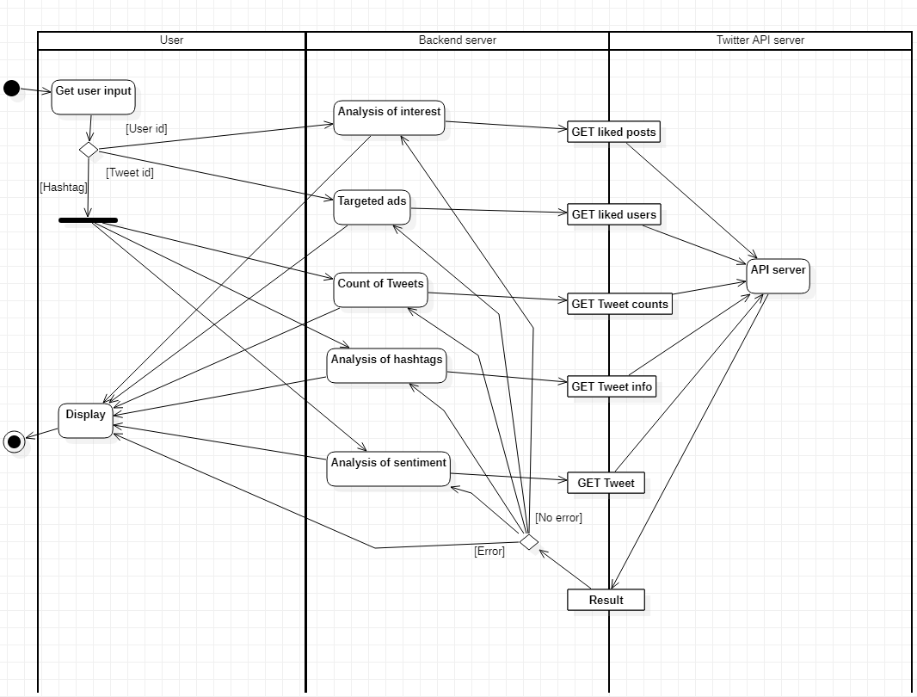

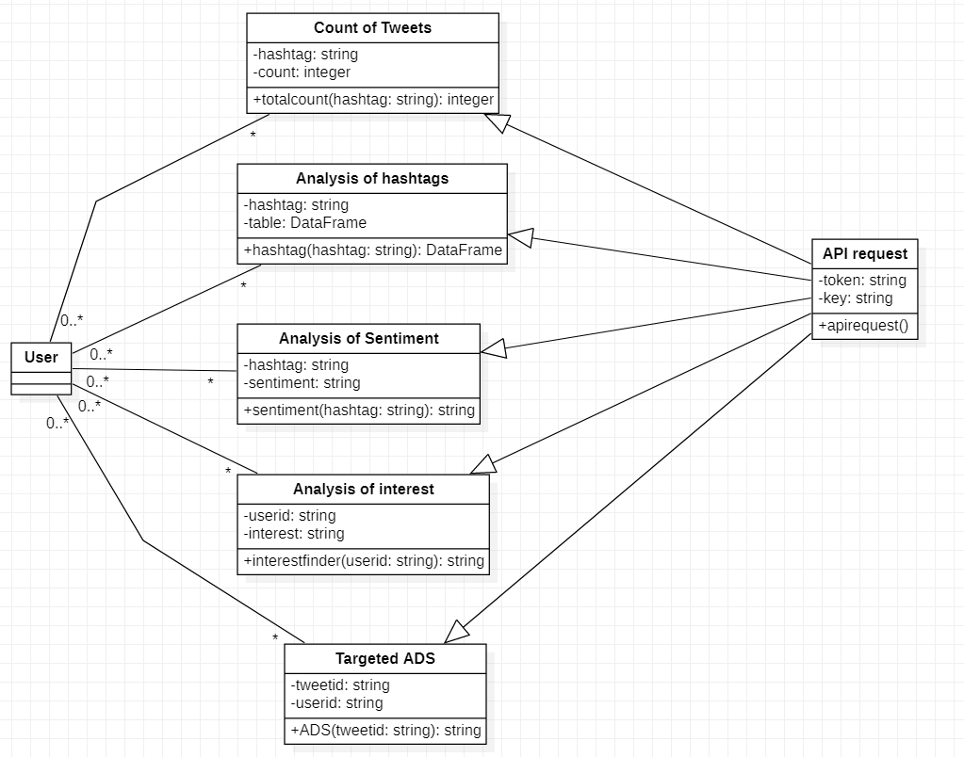

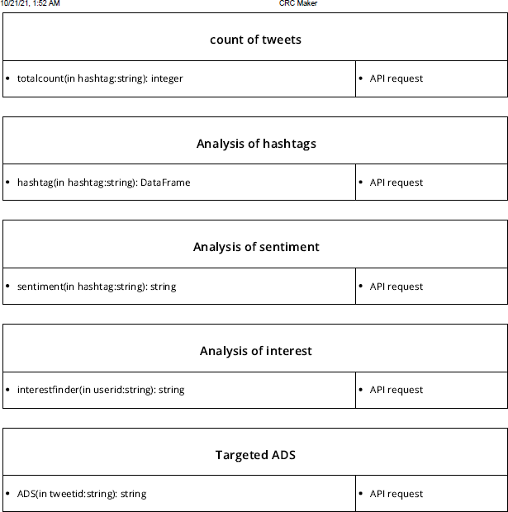

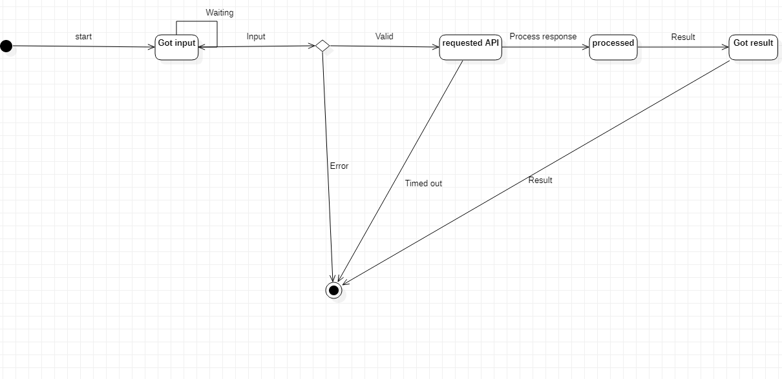

**Collaboration Diagram**

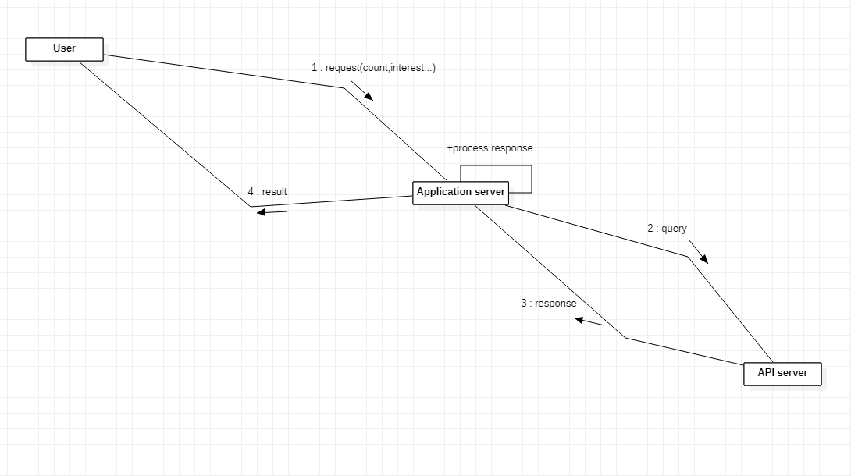

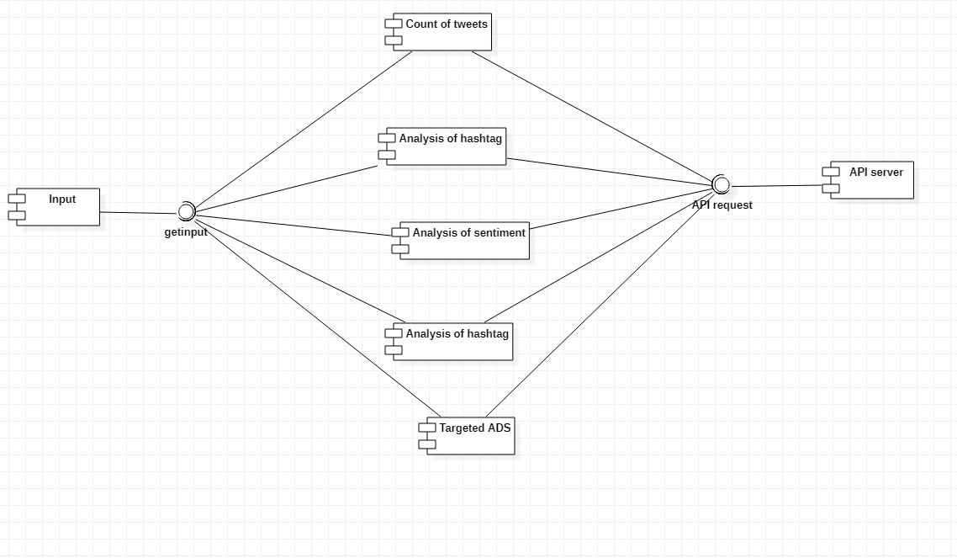

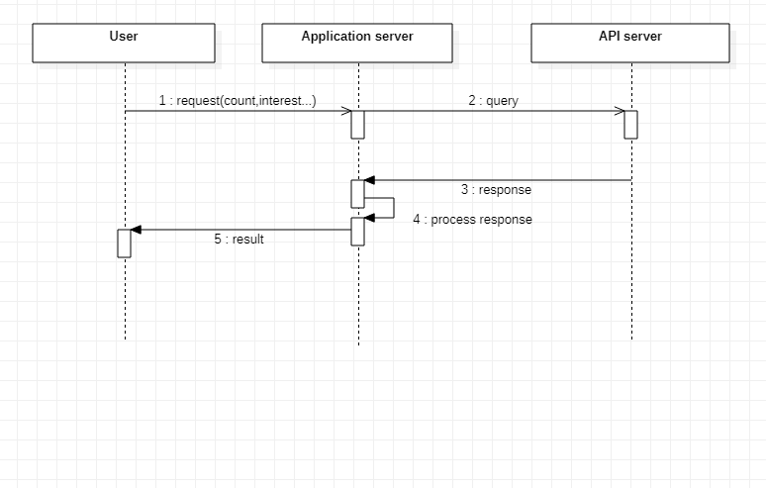

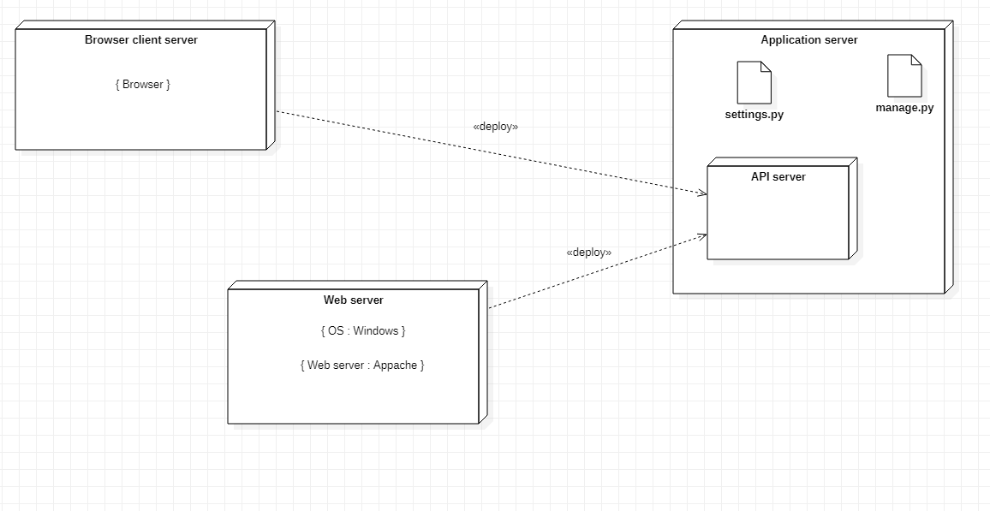

## Analysis of hashtags.py

#!/usr/bin/python

#-*- coding: utf-8 -*-

class Analysis of hashtags: def init (self):

self.hashtag = None self.table = None

def hashtag(self, hashtag): pass

## Analysis of interest.py

#!/usr/bin/python

#-*- coding: utf-8 -*-

class Analysis of interest: def init (self):

self.userid = None self.interest = None

def interestfinder(self, userid): pass

## Analysis of sentiment.py

#!/usr/bin/python

#-*- coding: utf-8 -*-

class Analysis of Sentiment: def init (self):

self.hashtag = None self.sentiment = None

def sentiment(self, hashtag): pass

## API request.py

#!/usr/bin/python

#-*- coding: utf-8 -*-

from Count of Tweets import Count of Tweets

from Analysis of hashtags import Analysis of hashtags from Analysis of Sentiment import Analysis of Sentiment from Analysis of interest import Analysis of interest from Targeted ADS import Targeted ADS

class API request(Count of Tweets, Analysis of hashtags, Analysis of Sentiment, Analysis of interest, Targeted ADS):

def init (self): self.token = None self.key = None

def apirequest(self, ): pass

#!/usr/bin/python

#-*- coding: utf-8 -*-

class Count of Tweets: def init (self):

self.hashtag = None self.count = None

def totalcount(self, hashtag): pass

## Targeted ADS.py

#!/usr/bin/python

#-*- coding: utf-8 -*-

class Targeted ADS: def init (self):

self.tweetid = None self.userid = None

def ADS(self, tweetid): pass

#!/usr/bin/python

#-*- coding: utf-8 -*-

class User: pass